Exploratory Testing (in Collaborative Form)

What is Exploratory Testing (in Collaborative Form)
# Source: AI Source: Provided by: [Data Path: Persons Table -> ID Column: 1, Name_En Column: Motasem Essam] -> From: [ChatGPT] on [8/24/2025]
Collaborative Exploratory Testing is when a group of people (testers, developers, product owners, business analysts, sometimes even end-users) explore the system together in real time, instead of testing individually.
The goal is to combine different perspectives, knowledge, and skills to discover defects, usability issues, and risks more effectively.

🔑 Key Characteristics
# Source: AI Source: Provided by: [Data Path: Persons Table -> ID Column: 1, Name_En Column: Motasem Essam] -> From: [ChatGPT] on [8/24/2025]
- Teamwork → Multiple roles (dev, QA, business) participate.
- Knowledge Sharing → Each participant contributes unique expertise (e.g., a tester thinks of edge cases, a dev knows internals, a PO knows user expectations).
- Real-Time Collaboration → Testing is done in sessions (workshops, pair testing, mob testing).
- Exploratory Nature → Still unscripted, but guided by charters/goals (e.g., "Explore checkout process under heavy load").
- Immediate Feedback → Issues found are discussed instantly and often fixed faster.

🛠️ Collaborative Forms of Exploratory Testing
# Source: AI Source: Provided by: [Data Path: Persons Table -> ID Column: 1, Name_En Column: Motasem Essam] -> From: [ChatGPT] on [8/24/2025]
- Pair Testing → Two people (tester + dev, or tester + business) explore the system together.
- Mob Testing → Whole team explores together, one person drives (controls keyboard), others guide.
- Exploratory Workshops → Group testing session with a defined timebox and goal.

📖 Example Scenario
# Source: AI Source: Provided by: [Data Path: Persons Table -> ID Column: 1, Name_En Column: Motasem Essam] -> From: [ChatGPT] on [8/24/2025]
Feature under test: Online payment system
- Tester: Explores different payment methods, tries invalid card numbers.
- Developer: Points out how backend validations work, suggests edge cases.
- Product Owner: Ensures tests align with user expectations (e.g., error messages are clear).
- Together: They discover that the system doesn’t handle expired cards gracefully (bad error message shown).

✅ Benefits
# Source: AI Source: Provided by: [Data Path: Persons Table -> ID Column: 1, Name_En Column: Motasem Essam] -> From: [ChatGPT] on [8/24/2025]
- More defects found faster (different perspectives).
- Better understanding of the system for everyone.
- Encourages team collaboration and shared ownership of quality.
- Real-time clarification of requirements and expected behavior.
- Builds trust and communication across roles.

⚠️ Challenges
# Source: AI Source: Provided by: [Data Path: Persons Table -> ID Column: 1, Name_En Column: Motasem Essam] -> From: [ChatGPT] on [8/24/2025]
- Needs timeboxing (can easily get unfocused).
- Requires facilitation to keep everyone engaged.
- Can be less effective without a clear test charter/goal.

is Exploratory Testing Collaboration-Based Approaches

1. Exploratory Testing as an Experience-Based Technique
# Source: AI Source: Provided by: [Data Path: Persons Table -> ID Column: 1, Name_En Column: Motasem Essam] -> From: [ChatGPT] on [8/24/2025]
- This is the classic definition:
  - Tester uses their skills, past experience, intuition, and domain knowledge to design and execute tests on the fly.
  - It’s often individual work (though it can be shared later).
  - Belongs to Experience-Based Techniques (alongside error guessing, checklist-based testing, etc.).
✅ Focus: "I explore the system using my knowledge and experience."

2. Exploratory Testing in Collaborative Approaches
# Source: AI Source: Provided by: [Data Path: Persons Table -> ID Column: 1, Name_En Column: Motasem Essam] -> From: [ChatGPT] on [8/24/2025]
- Here, exploratory testing is done together with others (e.g., devs, BAs, product owners, even users).
- Forms include pair testing, mob testing, workshops.
- Belongs to Collaboration-Based Test Approaches (alongside BDD, ATDD, SbE).
✅ Focus: "We explore the system together, combining perspectives and knowledge."

🔄 Are They the Same?
# Source: AI Source: Provided by: [Data Path: Persons Table -> ID Column: 1, Name_En Column: Motasem Essam] -> From: [ChatGPT] on [8/24/2025]
👉 They are related but not the same.
- Both rely on exploration instead of pre-scripted tests.
- But they belong to different testing categories depending on who is involved and how the activity is performed:
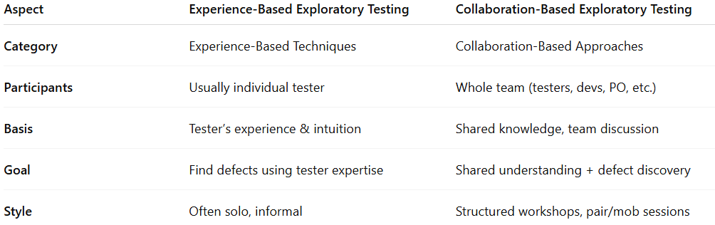
Aspect | Experience-Based Exploratory Testing | Collaboration-Based Exploratory Testing
Category | Experience-Based Techniques | Collaboration-Based Approaches
Participants | Usually individual tester | Whole team (testers, devs, PO, etc.)
Basis | Tester’s experience & intuition | Shared knowledge, team discussion
Goal | Find defects using tester expertise | Shared understanding + defect discovery
Style | Often solo, informal | Structured workshops, pair/mob sessions

⚖️ Summary
# Source: AI Source: Provided by: [Data Path: Persons Table -> ID Column: 1, Name_En Column: Motasem Essam] -> From: [ChatGPT] on [8/24/2025]
- Exploratory Testing (Experience-Based) → individual activity, relies on tester’s skills and intuition.
- Exploratory Testing (Collaboration-Based) → team activity, relies on multiple perspectives and collaboration.
👉 They share the same foundation (exploring the system without predefined test cases), but differ in approach and classification.

📝 Summary
# Source: AI Source: Provided by: [Data Path: Persons Table -> ID Column: 1, Name_En Column: Motasem Essam] -> From: [ChatGPT] on [8/24/2025]
Exploratory Testing in collaborative form = group-based, unscripted testing where testers, developers, and business stakeholders explore the system together.
It leverages multiple perspectives, encourages shared responsibility, and strengthens product quality.

